# MINI PROJECT REPORT

# On

# “Student management System”

### ****INTRODUCTION****

A student information system (SIS), student management system, school administration software or student administration system is a [management information system](https://en.wikipedia.org/wiki/Management_information_system) for education sector establishments used to manage student data.

It integrates students, parents, teachers and the administration. Student information systems provide capabilities for registering students in courses; documenting [grading](https://en.wikipedia.org/wiki/Grading_(education)), [transcripts](https://en.wikipedia.org/wiki/Transcript_(education)) of academic achievement and co-curricular activities, and the results of student [assessment](https://en.wikipedia.org/wiki/Educational_assessment) [scores](https://en.wikipedia.org/wiki/Test_score); forming student schedules; tracking student attendance; generating reports and managing other student-related data needs in an educational institution.

[Information security](https://en.wikipedia.org/wiki/Information_security) is a concern, as universities house an array of sensitive personal information, making them potentially attractive targets for security breaches, such as those experienced by retail corporations or healthcare providers. This machine similar to a typewriter with the window showing the questions. From then on continuous technological development has contributed to vast changes to LMS with the latest update in 2012 where the LMS is hosted in a cloud, hence freeing companies from the burden of maintaining in-house systems.

**System Design**

### WhatsApp Image 2023-11-27 at 11.59.08

### 

### TechnologyBucket

### “PYTHON”

Python is a [high-level](https://en.wikipedia.org/wiki/High-level_programming_language), [general-purpose programming language](https://en.wikipedia.org/wiki/General-purpose_programming_language). Its design philosophy emphasizes [code readability](https://en.wikipedia.org/wiki/Code_readability) with the use of [significant indentation](https://en.wikipedia.org/wiki/Off-side_rule). Python is [dynamically typed](https://en.wikipedia.org/wiki/Type_system#DYNAMIC) and [garbage-collected](https://en.wikipedia.org/wiki/Garbage_collection_(computer_science)). It supports multiple [programming paradigms](https://en.wikipedia.org/wiki/Programming_paradigm),including [structured](https://en.wikipedia.org/wiki/Structured_programming) (particularly [procedural](https://en.wikipedia.org/wiki/Procedural_programming)), [object-oriented](https://en.wikipedia.org/wiki/Object-oriented_programming) and [functional programming](https://en.wikipedia.org/wiki/Functional_programming). It is often described as a "batteries included" language due to its comprehensive [standard library](https://en.wikipedia.org/wiki/Standard_library).

Python strives for a simpler, less-cluttered syntax and grammar while giving developers a choice in their coding methodology. In contrast to [Perl](https://en.wikipedia.org/wiki/Perl)'s "[there is more than one way to do it](https://en.wikipedia.org/wiki/There_is_more_than_one_way_to_do_it)" motto, Python embraces a "there should be one—and preferably only one—obvious way to do it" philosophy. Alex, a [Fellow](https://en.wikipedia.org/wiki/Fellow) at the [Python Software Foundation](https://en.wikipedia.org/wiki/Python_Software_Foundation) and Python book author, wrote: "To describe something as 'clever' is not considered a compliment in the Python culture."

**Output Screen**

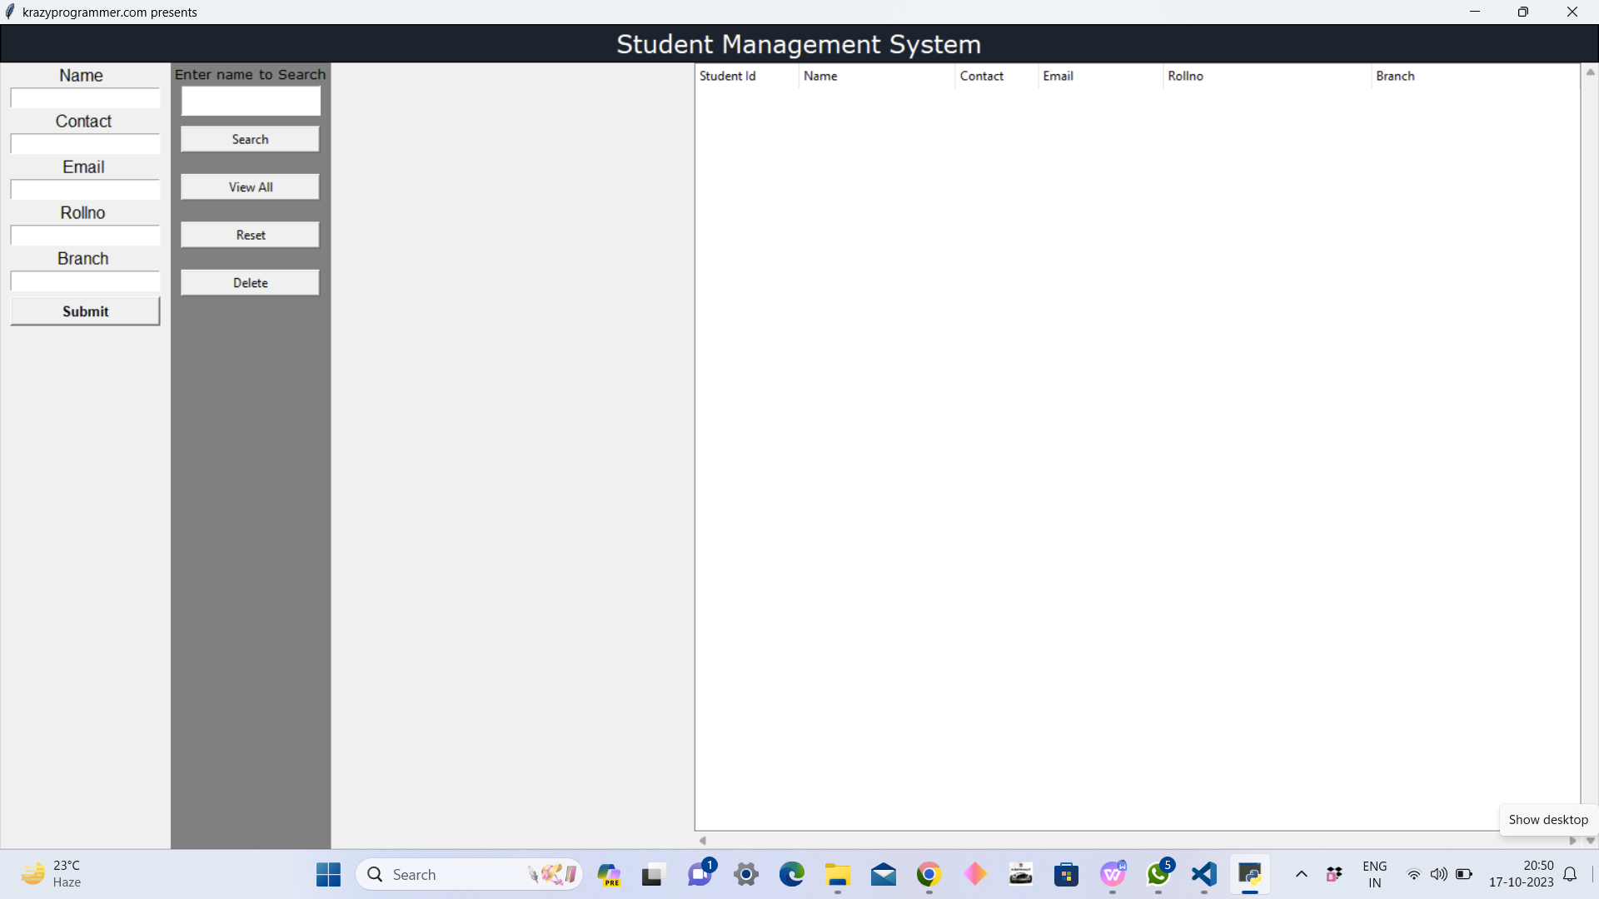

### References

* [https://en.wikipedia.org/wiki/Python(programming_language)](https://en.wikipedia.org/wiki/Python_(programming_language))
* <https://en.wikipedia.org/wiki/Student_information_system>
* https://en.wikipedia.org/wiki/Learning_management_system